Bash commands:
date - date and time
uname - os name
uptime - uptime and load
echo [string] - print string
myStr = [something] - set myStr to a string
myVar=[something] - set myVar to something

echo “$myVar” - print myVar (the $ does an escape)
for i in [nums]
do
[the thing in loop]
done
- for loops

pwd - path to current directory
touch [name of file.txt] - create new empty file
cat [name of file.txt] - print txt file contents out to console
rm [file name] - file
rmdir [directory name] - deletes empty directory
rm -rf [directory name] - deletes non empty directory
ls - lists files in current directory
ls -l - lists files in current directory with more information, such as user, bytes, time modified
cd [directory name(is blue)] - changes directory
cd .. - changes directory to parent directory
cd ~ - go to home directory automatically
tree - shows all files and directories in current directory in tree format
clear - clears the screen and starts new line at the top
mkdir [name of directory] - create a directory
mkdir [name of directory/name of new directory] - create a new directory within a directory
mv [source file] [target move to]/[target file name] - move file
mv [old name] [new name] - change name of file
(within A01.BashIntroduction/animal) mv apple.txt ~/A01.BashIntroduction/plant/fruit
cp [source file name] [what you want to name the file after its moved] [directory pathway] - copy file to another directory
cp BinarySearchTree.java BinarySearchTree.java ../P15.RBTIterator
For CS354: (be inside desktop)
scp -r samad@best-linux.cs.wisc.edu:/home/samad/private/cs354/p6 .
./[script name(is green)] - runs the script
./submit - run submit script to submit assignment
./submit -download - check what files were submitted
man [command] - opens manual page for the command with how to use, what parameters, what switches it has
sudo [stuff] - elevates permissions for user, administrator mode
nano [nameOfFile.txt] -
emacs [nameOfFile.txt] -
vim [nameOfFile.txt] -

Opening up CS400 files to import:Java compiling and running with JUnit:
javac -cp ../junit5.jar:. <TestFile>.java
java -jar ../junit5.jar --class-path=. --select-class=<MyTest> (MyTest → file name no extension)

JUnit Stuff:
Make sure to include @Test before each JUnit method
import org.junit.jupiter.api.Test;
import static org.junit.jupiter.api.Assertions.assertEquals;
import static org.junit.jupiter.api.Assertions.assertTrue;
import static org.junit.jupiter.api.Assertions.assertFalse;

sudo cs400 init - use this the first time you open CS400 on a new machine.
cs400 init - use this when accessing CS400 not for the first time (on your own personal device or school computer)

Java compiling and running regular:
javac [.java file]- java compiler, compile into .class file
java [.class file, but just name no .class extension] - runs class

All JUnit Assertions: https://junit.org/junit5/docs/5.0.1/api/org/junit/jupiter/api/Assertions.html

Submitting to Git:
cs400 submit - submit to Git
cs400 check – checks to see if you submitted

Installing Java for the first time on a new vm:
sudo apt update
sudo apt install openjdk-17-jdk-headless
Check: java —version
Check: vim/emacs App.Java

java [java file name] - run java program

ssh samad@vm-ip-number - log into vm
ssh samad@best-linux.cs.wisc.edu - log into one of the lab machines
ssh samad@[name of specific machine].cs.wisc.edu - log into specific lab machine

start in local terminal: scp samad@vm-ip-number:[file to copy] [destination on local]
Start in local terminal: scp [file to copy] samad@vm-ip-number:[destination on virtual]

vim commands:
vim [java file name] - open file or create file in vim editor
:q - exit
:w - write the changes to the file
:wq - save and quit file
i - change to insert mode, can edit the file
v - change to visual mode, copy and paste stuff
Esc - go back to normal mode

emacs commands:
emacs [java file name] - open file or create file in emacs editor
F10 - open menu
esc+x - run addon
es - command line addon
eww - browser addon
sudo snap install emacs —-classic

Version Control with Git
As you add new files or change files in a project, you want backups just in case something doesn’t work anymore. For a single user single file, just make a copy with a new name.
For a single user multiple files, copy all files into new directory:
mkdir backup1
cp *.java backup1
For multiple users and multiple files, use version control system, git.

Git shotta workflow :

Working Copy (directory)  Your actual machine, empty barrel | Staging area  Loading up the shell | Local repository  Locked and Loaded | global/remote repository  Boom.
Git checkout to go to your branch  git checkout [branch name] (this will either go to that branch or create a new one named that) | Files that we want in new version  git add [file] | Gives version a unique ID  Can checkout back to working copy  git commit -m “commit message” | Shared between team of developers  Can fetch into local  Can pull to working copy (fetch + checkout)  git push

Initial setup:
git config –global user.name=”[name]”
cat ~/.gitconfig
→ Sets name of who made changes, second line just there to check, dash is a double dash. Start with this first time around

Git commands:
git init - tells git to manage the folder
git status - checks status of the git workflow. Basically ls but for git, use multiple times.
git add [file] - adds file to staging area
git add --all - add all the files or changes to the repository.
git commit -m “commit message” - commits current staging area with commit message. Always use a descriptory commit message.
git commit --amend -m “commit message” - commits current staging area with commit message
git log - use this after a commit to get the commit ID, the author (you), and date. Use multiple times like ls.
git branch -m [name] - names branch
git branch - shows all local branches
git branch -r - shows all remote branches
git branch -a - shows all local and remote branches
git clone [the remote repo] [the local repo to clone into] - copy a remote directory to your own machine.
git remote -v - shows origins for fetches and pulls
git commit -a -m “commit message” - adds all files that git is already tracking to staging area and commits it
git push - push to remote
git pull - pull from remote
git config pull.rebase fault - merging while pulling
git checkout -b “name of branch” - creates branch
git checkout “name of branch” - goes to branch
git show (numbers of git commit):[file name]
git branch - lists branches, use multiple times like ls
git stash - record the current state of the working directory and the index, but want to go back to a clean working directory
touch .gitignore - ignores hides from the output of git status

Lambda Expressions:
Condition<Integer> odd = value → value % 2 ==1;
list.filter (value → value ==4 || value ==6);

Allows for this shit to be passed to a parameter

Try java.util.function Predicate<T> defined in java api

TIME COMPLEXITIES (MEMORIZE THIS)
Binary Search Trees in terms of Nodes:
Search: Best case scenario: O(log n) Worst case scenario: O(n)
Insert: Best case scenario: O(log n) Worst case scenario: O(n)
Delete: Best case scenario: O(log n) Worst case scenario: O(n)

Red-Black Trees in terms of Nodes:
Search: Best case scenario: O(1) Worst case scenario: O(log n)
Insert: Best case scenario: O(1) Worst case scenario: O(log n)
Delete: Best case scenario: O(1) Worst case scenario: O(log n)

Red-Black Trees AND Binary Search Trees in terms of Height:
Search: Best case scenario: O(1) Worst case scenario: O(h)
Insert: Best case scenario O(1) Worst case scenario: O(h)
Delete: Best case scenario: O(1) Worst case scenario: O(h)

Linear sorting:
Comparison sorts:
bubble sort O(n^2)
heap sort, merge sort, quick sort O(n*logn)

Stable: keep relative order for identical numbers
Unstable: order could be switched for identical numbers

Bubble and merge are stable
Heap and quick are unstable

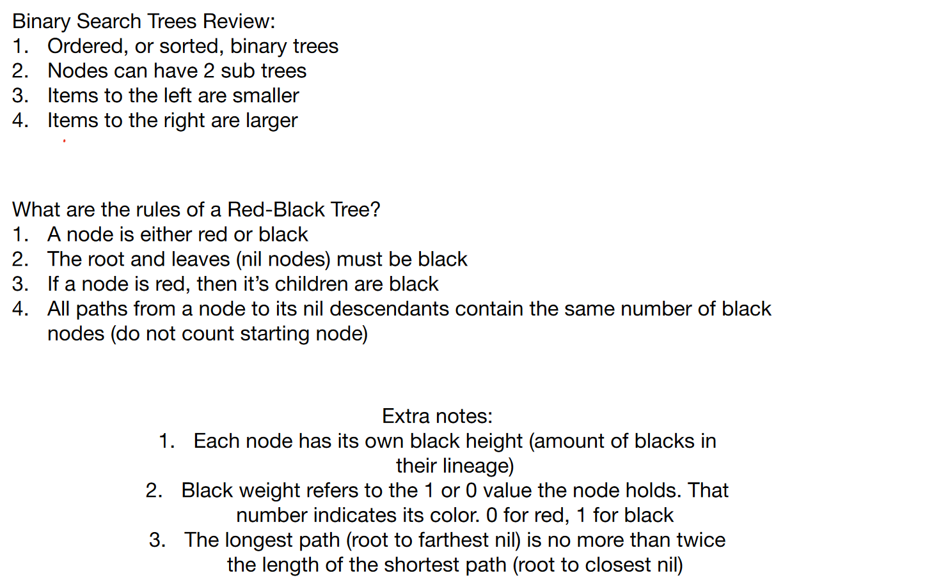
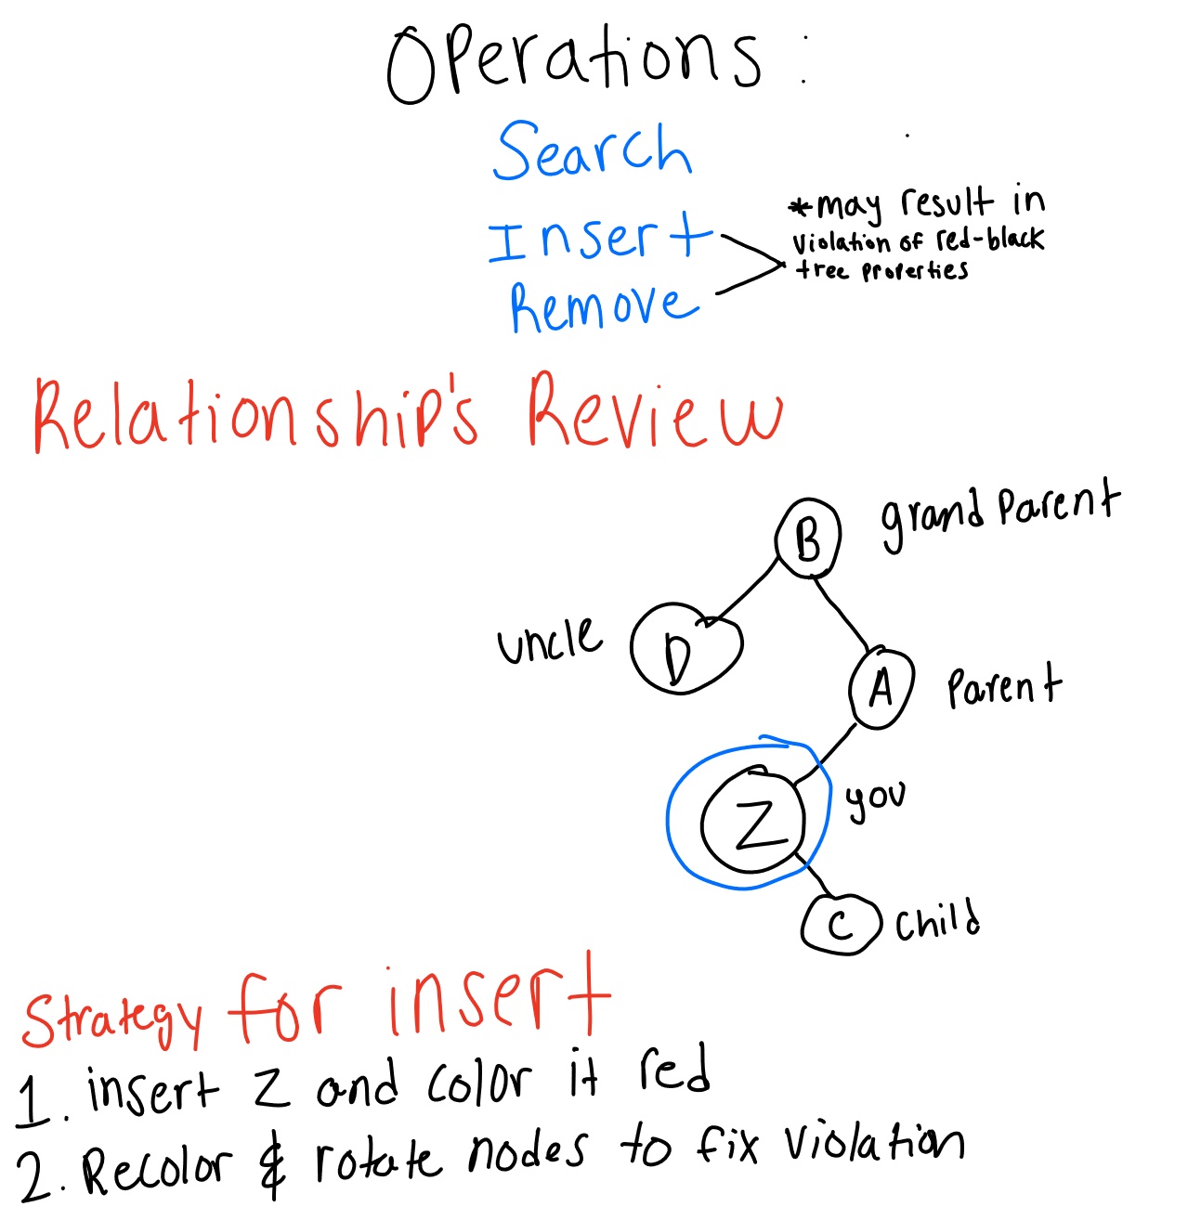

RED BLACK TREE INSERT
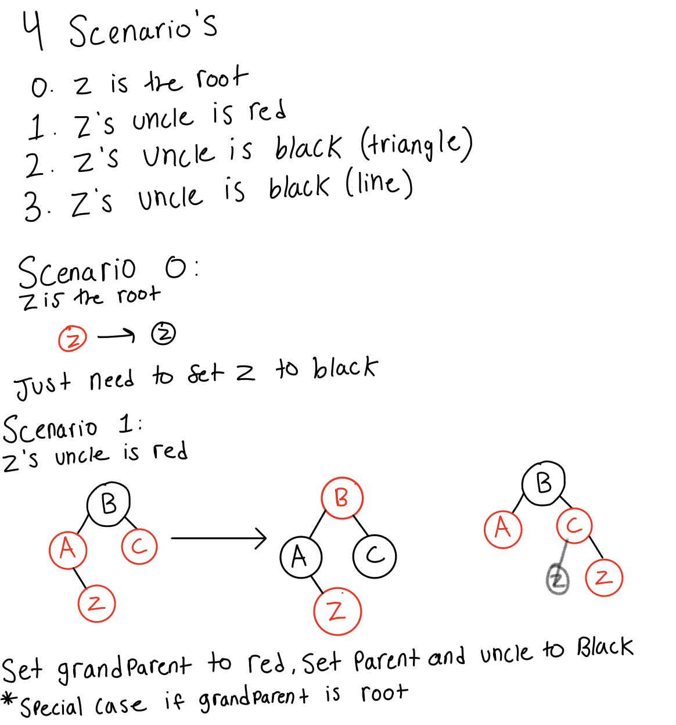

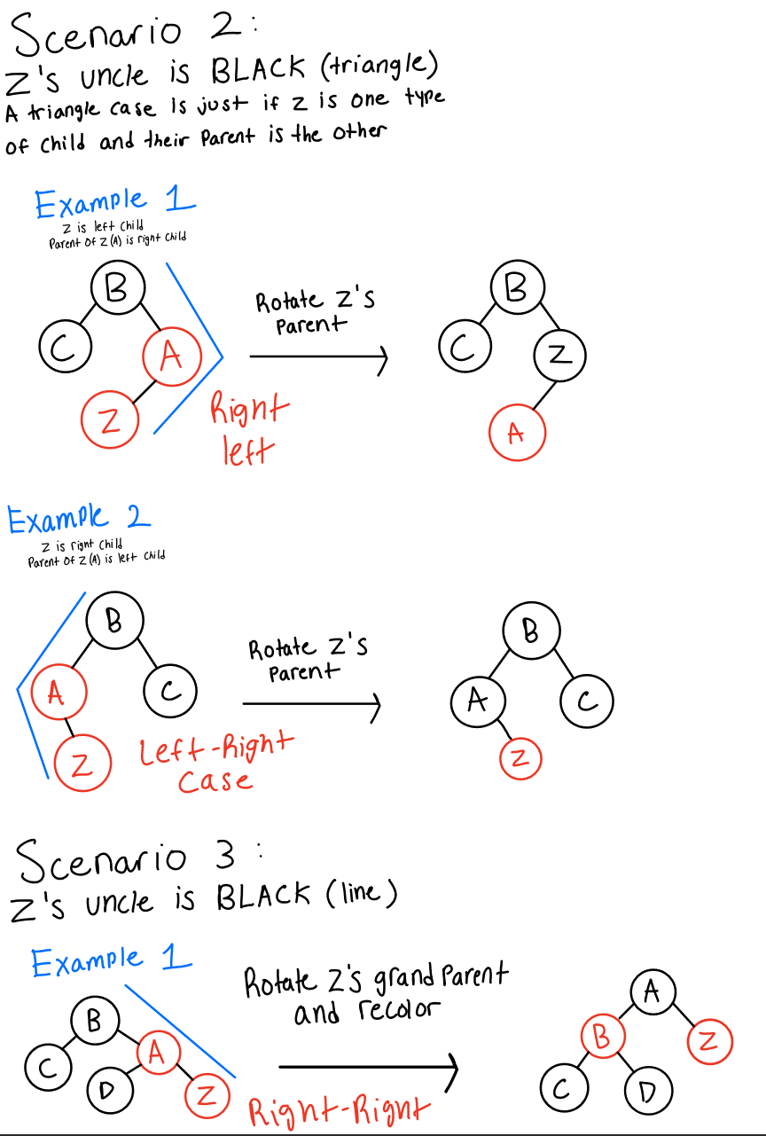
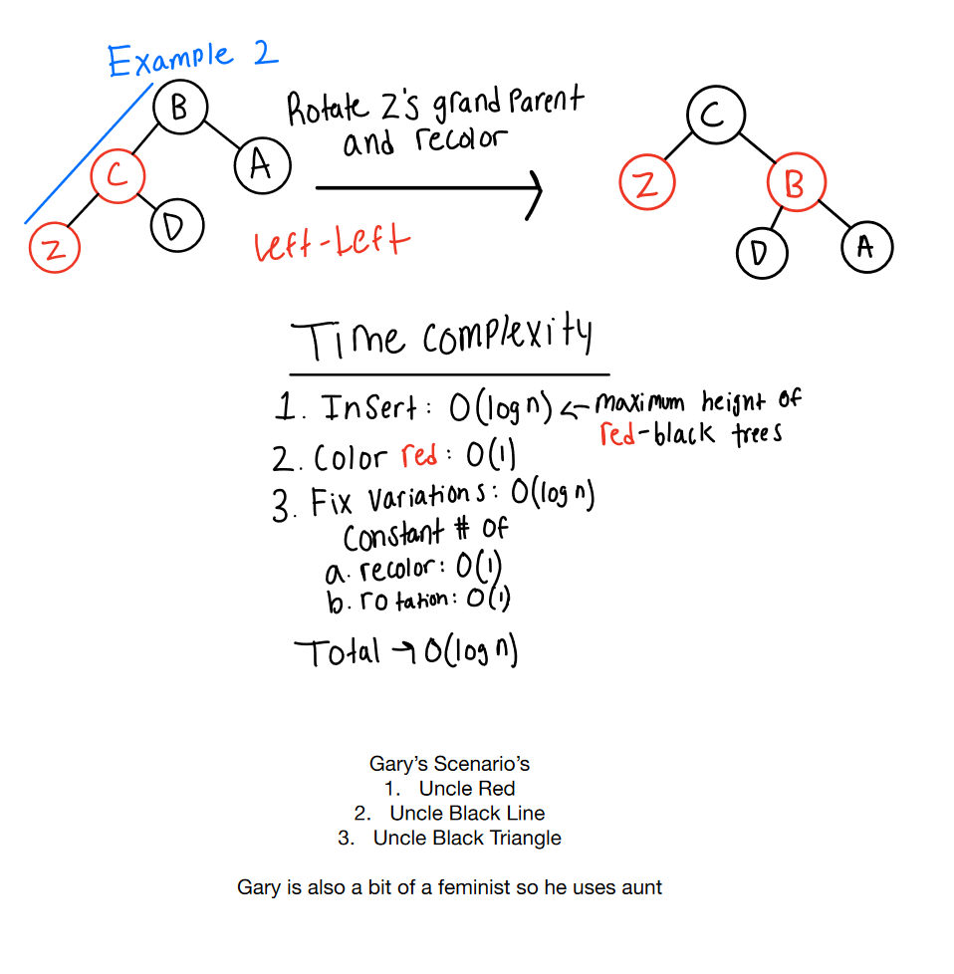

RED BLACK TREE REMOVE

Case 1: Node is red with no children
Result: Just remove the node, no further changes necessary
Case 2: Node is red with 1 black child
Result: Make black child take the place of the red node.

Case 3: Node is red with 2 black children
Result:
- Replace with closet next-in-line node to replace the one you’re deleting
- Swap the red node with new placement
- If the replacement you swapped in was black, you now have a double black issue
Double Black Issue:
- If the sibling of the double black node is red, rotate and recolor to make the sibling black and continue with adjustments.
- If the sibling is black and has a red child, rotate to use that red child to correct the black height imbalance.
- If the sibling is black and has no red children, you may have to recolor and potentially pass the double black issue up to the parent.
- Move up the tree and fix any further issues

Case 4: Node is black with no children
Case 4.1:
Case 4.2:
Case 4.3:
Case 4.4:

Case 5: Node is black with 1 red child

Case 6: Node is black with 2 red children

Case 7: Node is black with 1 black child

Case 8: Node is black with 2 black children

JARs:
jar cf “name” “classfiles” - creates jar file with classes
java -cp “jar file”:(optional)”check 2nd folder (use . for current file)” “classfile we want to run” - runs class name using the jar
jar cfe “name of jar” “class name that is entry point” “classfiles” - creates jar file with classes and entry point
java -jar “jar file with entry point”-runs jar

Testing and JUnit:
3 dimensions for tests:
Unit Tests vs Integration Tests:
Unit tests test a single unit of code we write, like single method or single class, in isolation
Integration tests tests how many units of code interact with each other
Black Box (Opaquebox) vs White Box:
Black Box (Opaquebox) tests test methods and functions for an abstract data type or interface that can be used for many different implementations of that data type or interface
White Box tests test specific parts of the integration of an abstract data type or interface
Output tests vs Property tests:
Output tests test an input and see if the output is the expected output
Property tests test the properties of the implementation directly instead of using output

JUnit library:
import org.junit.jupiter.api.Test - import Test
Import org.junit.jupiter.api.Assertions - import Assertions
Import org.junit.jupiter.api.BeforeEach - import Before Each
Import org.junit.jupiter.api.AfterEach - import After Each
Import org.junit.jupiter.api.BeforeAll - import Before All
Import org.junit.jupiter.api.AfterAll - import After All
wget http://pages.cs.wisc.edu/~cs400/junit5.jar - download the jar file
javac -cp .:junit5.jar FileName.java - compile java class and tell where to look for imports
java -jar junit5.jar --class-path=. --include-classname=.* --select-class=FileName(no .java or .class) - run junit tests

For makefile:
runTests: FileNameTests.class
java -jar junit5.jar --class-path=. --include-classname=.* --select-class=FileNameTests

FileNameTests.class: FileNameTests.java FileName.class
javac -cp .:junit5.jar FileNameTests.java
es to get words
Node that ends a word set the final bit boolean to true;

